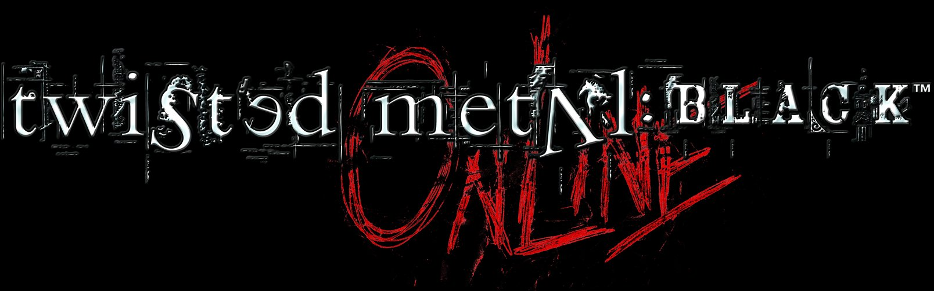

KEY FEATURES:

- Fast paced multi-player car combat set in dark, gritty environments and inhabited by serial killers and psychopaths.

- Removal of in-game video clips to lower the age rating.

- 8 game modes including Death Match, Last Man Standing, Fox Hunt and Collector

- 20 levels – all levels featured in the current Twisted Metal: BlackTM product.

- All the playable vehicles (15) from the multiplayer modes in Twisted Metal: BlackTM.

- Up to 8 players online.

- Game modifiers available in ALL game modes e.g. single weapon, single vehicle, power relics, unlimited weapons, handicap and friendly fire.

- Twisted Metal: Black OnlineTM will use same set of pickups that exist in the original game. Pickup regeneration rates will be based on number of players currently playing in a level. As more players connect to a game, the pick-ups will regenerate at a faster rate.

- All of the vehicles will be available and can be selected by the player if the game mode allows. No vehicles can be locked out.

- The maximum number of specials that any vehicle can stockpile is 5.

- More than one player may select the same vehicle.

- Pedestrian and fodder vehicles in the levels are not supported.
- Each level has unique environmental interactive objects that will have to be synchronised. Some objects have been removed from the level due to synchronisation issues.

For more information on SCEE titles, please visit our website
www.playstation.com

Developer: Incog Inc. Entertainment/SCEA Santa Monica Studios Genre: Car Combat/Driving and shoot’em up
No. of Players: 1-8 Platform: PlayStation®2
Accessories: Network Adaptor (Ethernet) (for PlayStation®2), Analog Controller (DUALSHOCK®2),
Memory Card (8MB) (for PlayStation®2)
Release Date: Staggered rollout with Network Adaptor starting with UK in May 2003

Sony Computer Entertainment Europe Ltd.

Sony Computer Entertainment Europe, based in London, is responsible for the distribution, marketing and sales of PlayStation, PS one and PlayStation 2 hardware and software in 102 territories across Europe, the Middle East, Africa and Oceania. At the end of September 2002, over 36 million PlayStation units had been shipped across these PAL territories and over 92 million worldwide. Between its European debut on 24 November 2000 and 15 January 2003, over 16 million PlayStation2 units have been shipped across the PAL territories, over 50 million world-wide, making it one of the most successful computer entertainment products in history.

PlayStation and the PlayStation logo, PS one and PS2 are registered trademarks of Sony Computer Entertainment Inc. All other trademarks are the property of their respective owners.

More information about PlayStation products can be found at http://www.scee.com and http://www.playstation.com .

